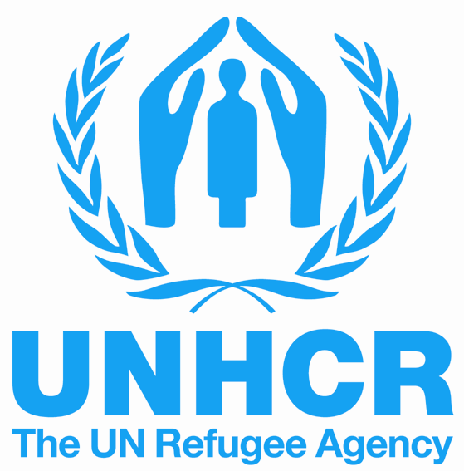

INVITATION FOR APPLICATIONS

Humanitarian Negotiations workshop

Bangkok, Thailand, 27-30 March 2017

The UNHCR’ Regional Centre for Emergency Preparedness |eCentre, is pleased to call for applications to the Humanitarian Negotiations workshop for UNHCR partners and staff in the Asia-Pacific region.
Overview
You are driving in an area affected by conflict trying to reach people who need your assistance, but your vehicle has been turned back a checkpoint. You have arranged a meeting with the Zone Commander to persuade him to grant you access. As you prepare for the appointment, you reflect on the fact that lives many depend of the results of your meeting.
Many aid workers have faced situation like this, but few have received training on the skills needed to negotiate successfully on behalf of their organizations and beneficiaries. This is because most courses on negotiation focus on using these skills in a business context, which is often quite different from the challenges faced by humanitarian agencies in the field in the complex emergency context.
In the eCentre workshop, participants learn the skills and techniques of negotiation applied in situations where humanitarians must use them: negotiation with government interlocutors, non-state and irregular actors (including armed elements), partner agencies, fellow staff members and sometimes beneficiaries.
In the Humanitarian Negations workshop, participants hone in on the specific skill set needed in situations where access, protection, respect for rights and humanitarian space are at stake. The workshop features extensive use of negotiation exercises. The ultimate goal is to develop humanitarian workers who are better able to advocate and defend position on behalf of heir agencies and beneficiaries.
Target participants
This initiative is designed for UNHCR partners in Asia and the Pacific (including government, NGO, military, civil emergency, UN and regional body actors) who are involved in, or expect to soon be involved in, emergency preparedness and response work in the humanitarian context. Applications from UNHCR staff are encouraged, but the majority of participants will represent a diverse array of partner organisations from throughout the region.
Main themes of the course
- Analysing your negotiation position and that of others
- Approaches to reaching mutually beneficial solutions
- Techniques for reducing and defusing hostility in others
- Negotiation strategies in emergency and protection situations
- Culture, gender and negotiation
- Recognizing and responding to unfair, or ”hardball’ tactics

Applying for this course
If you would like to apply to participate in this course, please fill out the attached application form and send it to the eCentre by 10 February 2017, at ecentre@unhcr.org (copy to kozelets@unhcr.org). All applicants are encouraged to coordinate their application with UNHCR office, as the priority will be given to organizations cooperating or planning to cooperate with UNHCR. Kindly note that this event will be conducted in English and thus participants must be strongly proficient in spoken and written English. The UNHCR eCentre will cover the costs of participation for accepted applicants in accordance with its funding policy. Please note that considering the limited number of places at the workshop, not all applicants could be selected, therefore we apologize for this in advance and would make every effort to consider these applications – in consultation with sending offices – for the workshops at a later stage.

