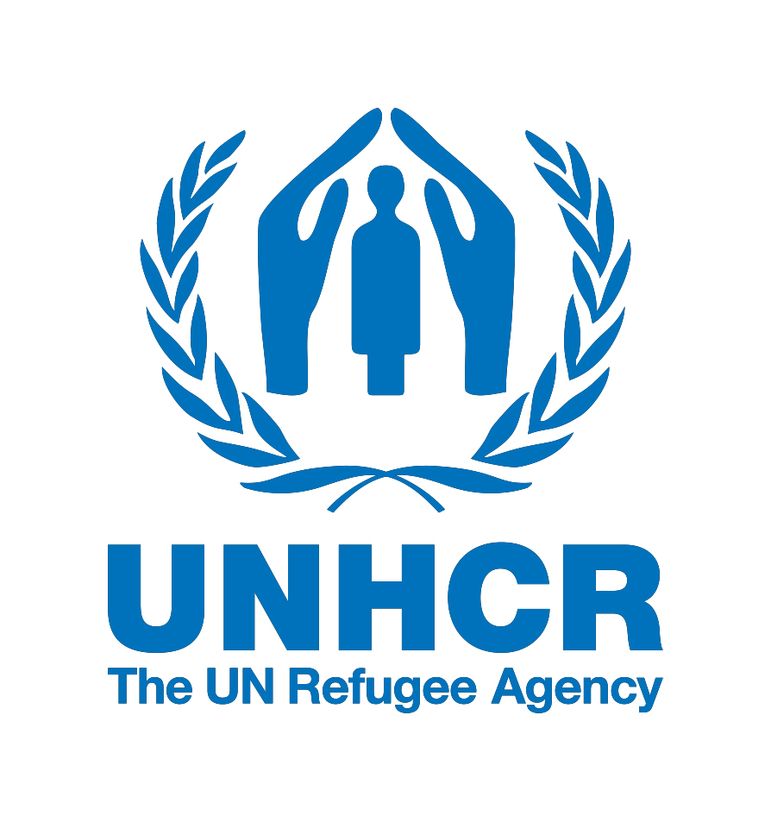

INVITATION FOR APPLICATIONS

Basics of International Humanitarian Response (BIHR)

Fort Thanarat, Hua Hin, Thailand | 15 – 23 October 2017

The UNHCR’ Regional Centre for Emergency Preparedness |eCentre, is pleased to call for applications to the BIHR workshop for UNHCR partners and staff in the Asia-Pacific region.
Overview
This field-based workshop will provide a comprehensive introduction to the most current international standards and approaches during the preparedness and response phase of a humanitarian emergency – whether caused by armed conflict, human rights violations or natural disasters. Highly interactive and participatory, this event features realistic field simulations, hands-on skills practice, role plays, facilitated classroom discussion, and group work. Participants will have the opportunity to assess their own capacities and better understand the approaches of partner agencies, with a view to strengthening emergency response capacity and collaboration amongst a diverse network of partners.
Target participants
This initiative is designed for UNHCR partners in Asia and the Pacific (including government, NGO, military, civil emergency, UN and regional body actors) who are involved in, or expect to soon be involved in, emergency preparedness and response work in the humanitarian context. Applications from UNHCR staff are encouraged, but the majority of participants will represent a diverse array of partner organisations from throughout the region.
Main themes of the course
- Emergency preparedness
- Emergency assessment basics
- Coordination of large-scale, multi-sectoral emergency responses
- Human rights and protection standards in emergency response
- International standards in sectoral responses (shelter, food, water, sanitation, hygiene, etc)
- Registration and distribution systems in emergencies
- Civil-military relations and humanitarian space issues
- Safety and security in the field, first aid, and stress management
- Field communications, map reading and navigation
- Humanitarian negotiation and working with the media in emergencies
What you will get from attending this course
- A better understanding of international frameworks, standards and effective practices for preparing and responding to humanitarian emergencies
- An appreciation of the importance of coordinating with diverse partners, and experience achieving this through practical field exercises
- Enhanced confidence in your ability to work successfully in an emergency
- Strengthened ties with emergency management partners and the UNHCR eCentre network
Applying for this course
If you would like to apply to participate in this course, please fill out the attached application form and send it to the eCentre by Monday, 4 September 2017, at kosaka@unhcr.org (copy to ecentre@unhcr.org). Kindly note that this event will be conducted in English and thus participants must be strongly proficient in spoken and written English. The UNHCR eCentre will cover the costs of participation for accepted applicants in accordance with its funding policy.

